Data Forwarder:
- Upload the code to ESP32 with delay() < 500s for > 2Hz.
- Close the Arduino IDE

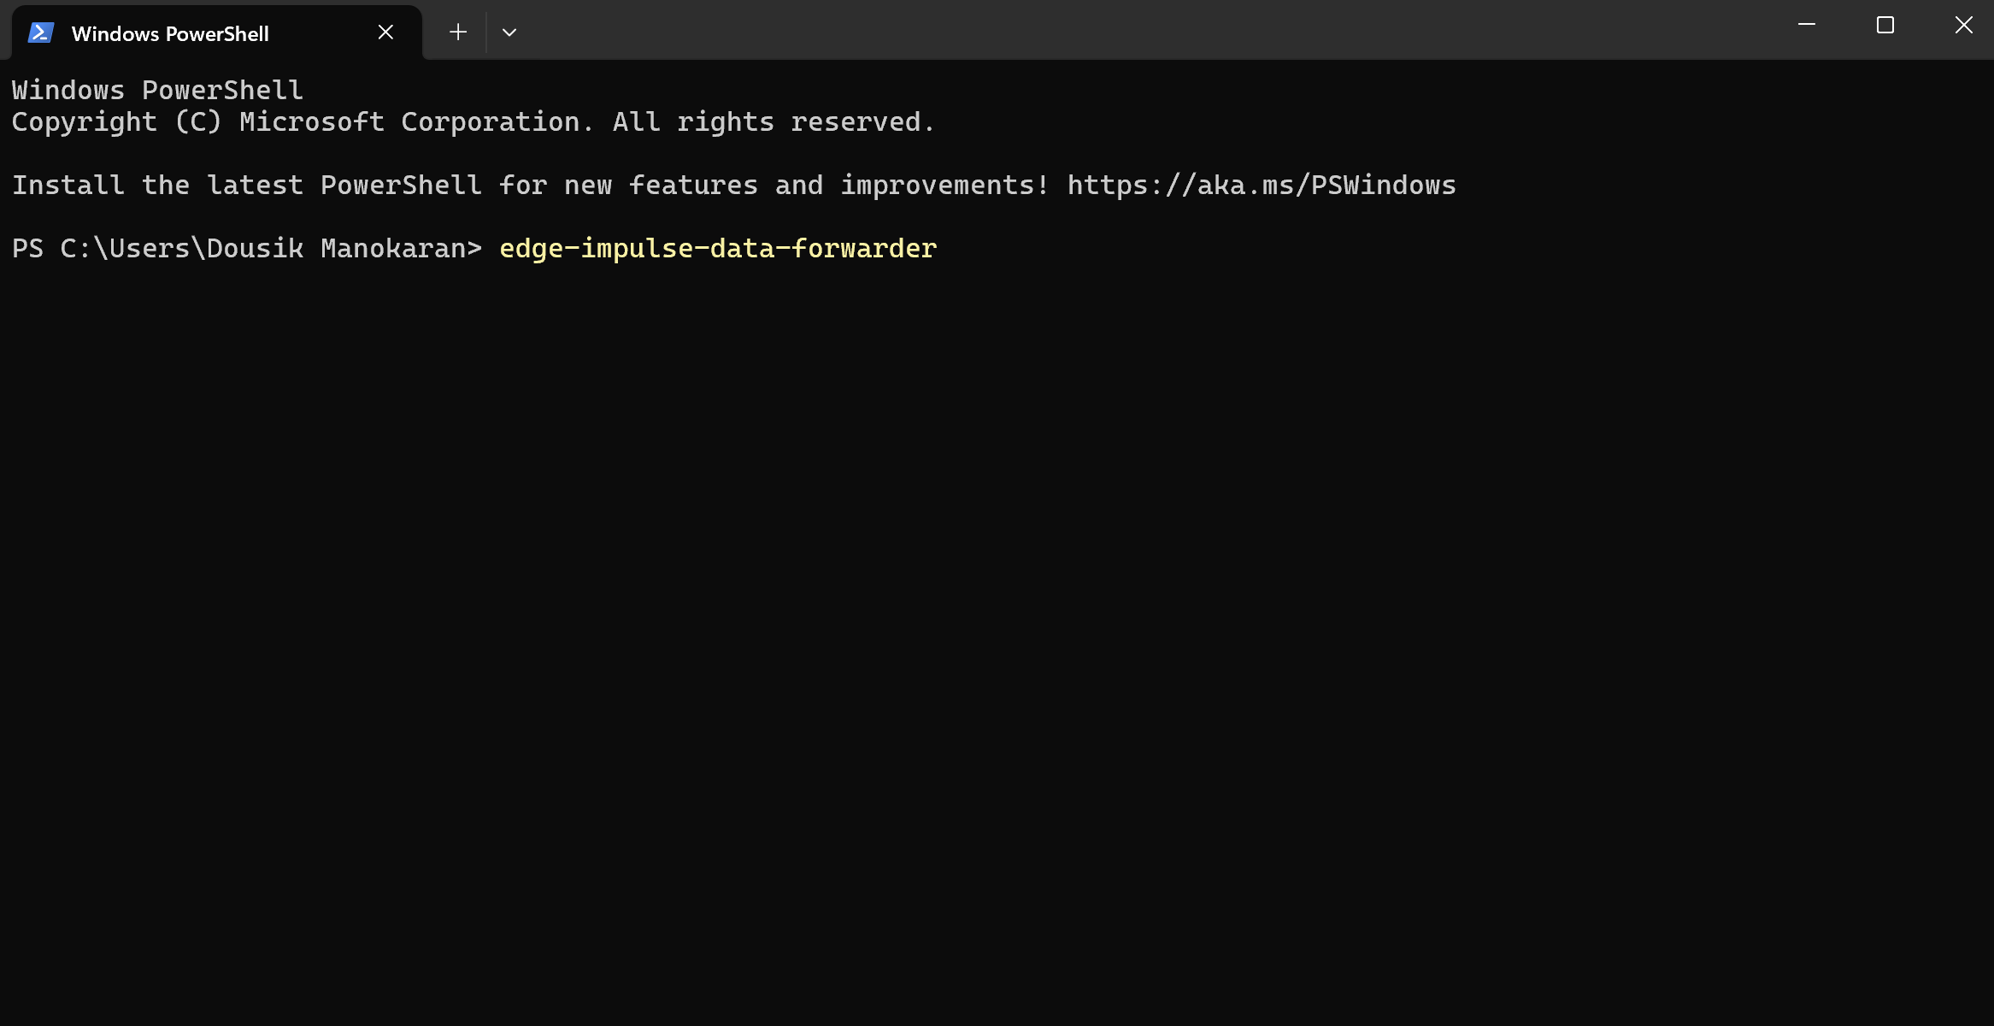
- 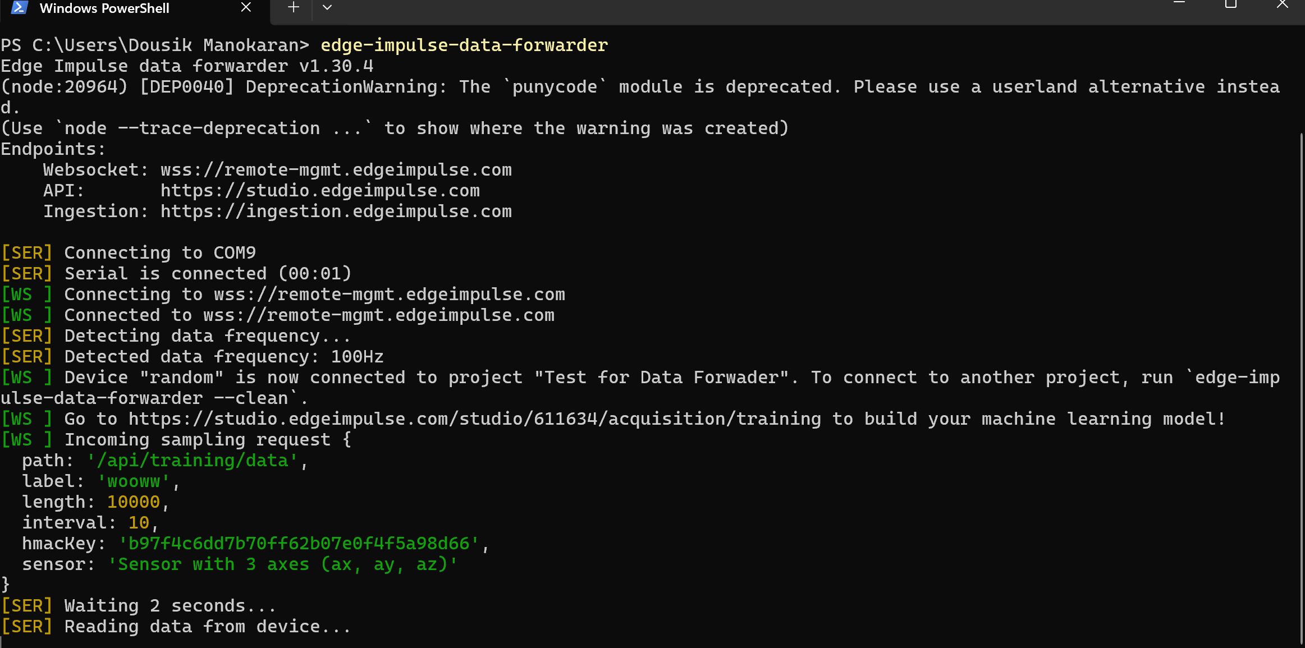
- 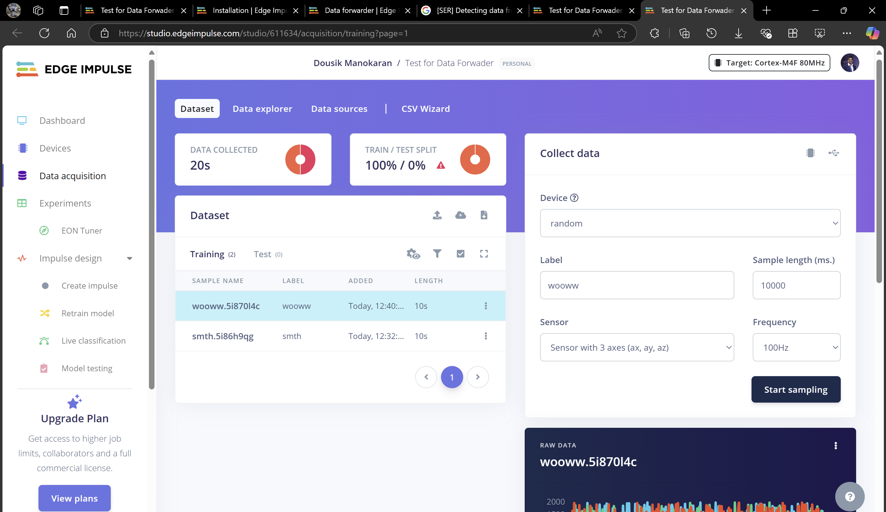
- Sample multiple times with different labels

